**Task 3 – Report**

**1. Motivation**

The motivation behind this role challenge is to develop an effective object detection-based deep learning model for identifying specific fetal brain structures in 2D ultrasound images. The accurate detection of structures like cranium, midline falx, and Cavum septum pellucidum (CSP) can provide valuable insights into potential medical conditions in fetuses. Ultrasound imaging is chosen as it's safe, accessible, and widely used for detecting central nervous system anomalies in fetuses.

**2. Abstract**

In this report, We present our approach to solving the fetal brain structure detection problem using an object detection model. We focus on using the YOLOv8 architecture and discuss our methodology for data preprocessing, augmentation, model selection, and experimental setup. We analyze the results obtained from our trained model and highlight key findings relevant to accurate structure detection in ultrasound images.

**3. Introduction**

The chosen method involves using the YOLOv8 model due to its demonstrated accuracy and suitability for real-time deployment. We aim to detect three classes of fetal brain structures - MIDLINE_FALX, CSP, and CHOROID_PLEXUS. The model's ability to identify these structures accurately can aid in diagnosing medical conditions.

**4. Data PreProcessing/Analysis**

**I** initiated the process by annotating the dataset using Roboflow tools, creating bounding box annotations for each structure class. To facilitate training and improve efficiency, images were resized to a standardized 640x432 resolution. Data augmentation techniques, including rotational variations (5%-10%) and image blur (2.5px), were applied to mimic real-world scan scenarios. Ground truth checks ensured accurate annotations.

4.1 Annotation of Images: The dataset was meticulously annotated using Roboflow tools, ensuring accurate bounding box annotations for each of the three target fetal brain structures - MIDLINE_FALX, CSP, and CHOROID_PLEXUS. This step was essential to provide the model with ground truth information for training.

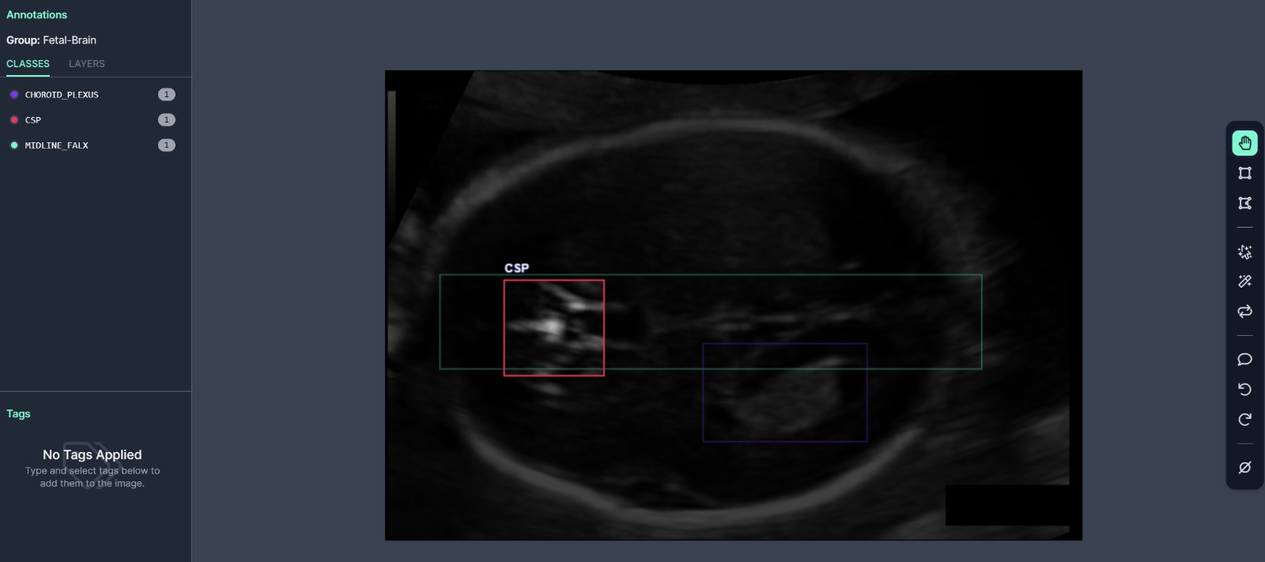

4.2 Data Preprocessing and Augmentation: To enhance the dataset's size and promote model generalization, data augmentation techniques were applied. These included introducing rotational variations (5%-10%) to mimic real-world probe positioning, which can vary during ultrasound scans. Additionally, a blur factor of 2.5px was incorporated to simulate image clarity fluctuations, enhancing realism. These augmentations aimed to improve the model's ability to detect structures under diverse ultrasound scan scenarios.

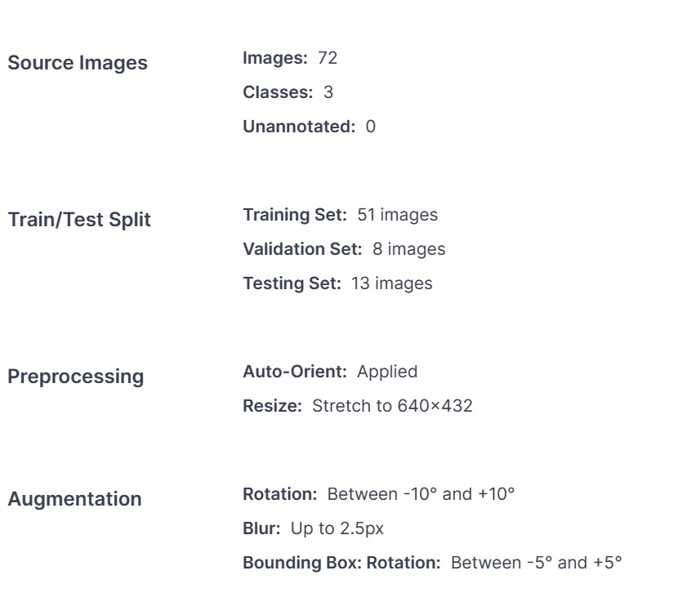

4.3 Standardization of Image Size: Recognizing the importance of standardization, all images were resized to a uniform 640x432 resolution. This adjustment not only facilitated a more efficient training process but also ensured that the model's performance was consistent across various image sizes.

**5. Model Architecture**

The selection of an appropriate model architecture is crucial for accurate object detection, especially in the context of medical imaging. In our pursuit to identify fetal brain structures in ultrasound images, **I opted for the YOLOv8 architecture**. This choice is backed by several factors that align with the specific challenges posed by ultrasound images and our goal of real-time detection.

5.1 Multi-Scale Detection Strategy: YOLOv8 employs a multi-scale detection strategy, allowing the model to simultaneously detect structures of varying sizes within the same image. This is particularly important in fetal ultrasound images, where structures like the cranium and the midline falx may exhibit significant size variations due to varying gestational ages and imaging angles. By analyzing multiple scales, YOLOv8 ensures that structures are identified regardless of their dimensions.

5.2 Feature Pyramid Network (FPN): YOLOv8 incorporates a Feature Pyramid Network, which enhances the model's ability to extract relevant features from different scales of the input image. This is especially advantageous when dealing with ultrasound images, as features relevant to structure identification might appear at different resolutions. The FPN aids in capturing these features and fusing them into a cohesive representation, improving detection accuracy.

5.3 Real-time Inference: Fetal ultrasound imaging often involves real-time examinations, making the ability to process images rapidly a critical requirement. YOLOv8's design emphasizes efficiency and speed, allowing us to deploy the model in clinical settings where immediate feedback is essential. This aligns well with our objective of providing accurate and timely medical insights.

5.4 Transfer Learning Potential: YOLOv8's architecture also enables easy integration of transfer learning. Pre-trained weights from a general object detection task can be fine-tuned on our specific fetal ultrasound dataset. This approach capitalizes on the knowledge gained from broader datasets, accelerating the convergence of our model and improving its performance on our specialized task.

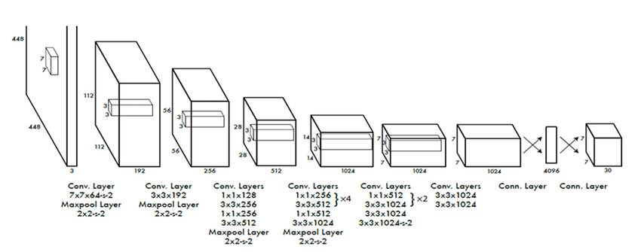5.5 Interpretability: YOLOv8's architecture lends itself to interpretability. The model generates bounding box predictions along with associated class probabilities, aiding medical professionals in understanding and verifying the detection results. This transparency is crucial in medical applications, where reliable and interpretable results are essential.

**6. Experimental Setting**

* Data Set Split: The dataset was divided into training, validation, and testing sets using a standard split ratio. This separation allowed me to train the model on a diverse range of images and then evaluate its performance on previously unseen data.
* We utilized the Ultralytics library to streamline training, evaluation, and visualization of our YOLOv8 model. The model was trained using the dataset, and an appropriate data split strategy was employed. The experimental setup included the selection of optimizers, loss functions, and hyperparameters to optimize model performance.

**7. Hypothesis Tried**

* In the experimentation, I considered several hypotheses to improve model performance. These included variations in backbone architectures, changes in loss functions, and exploration of pre-training strategies. These hypotheses were aimed at enhancing the model's ability to accurately detect fetal brain structures.

**8. Results**

* The trained YOLOv8 model exhibited promising results in detecting MIDLINE_FALX, CSP, and CHOROID_PLEXUS structures in fetal ultrasound images. The model demonstrated the ability to generalize well across images with varying degrees of zoom and rotation, thanks to the applied data augmentation techniques. Further analysis of precision, recall, and F1 scores highlighted the model's effectiveness.

**8.1 Sample Images after Preprocessing**: After the preprocessing steps, the dataset consisted of 174 images. These images represented a variety of fetal ultrasound scenarios, encompassing different zoom levels, rotation angles, and clarity fluctuations.

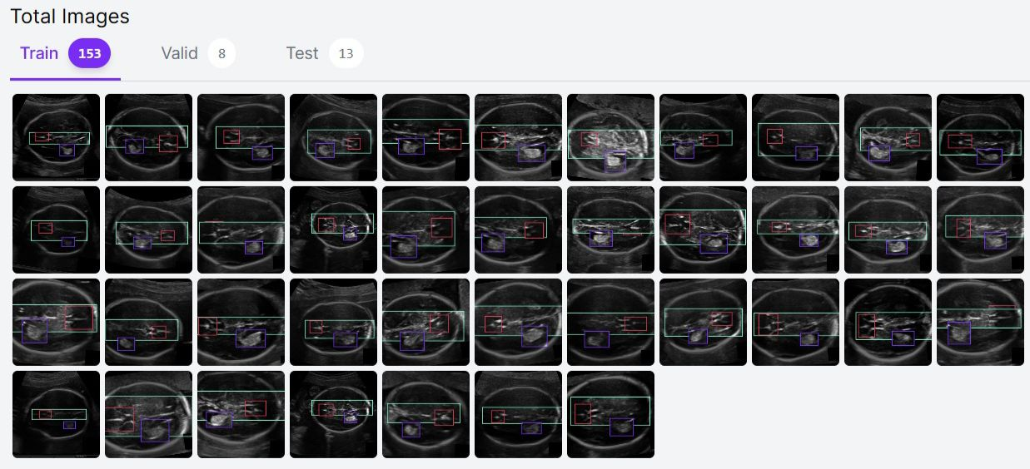

**8.2 Predicted Sample:** A typical result of the model's predictions is shown in a sample image where MIDLINE_FALX, CSP, and CHOROID_PLEXUS structures have been accurately identified using bounding boxes. This visually demonstrates the model's capability to detect structures of medical significance in real-world ultrasound images.

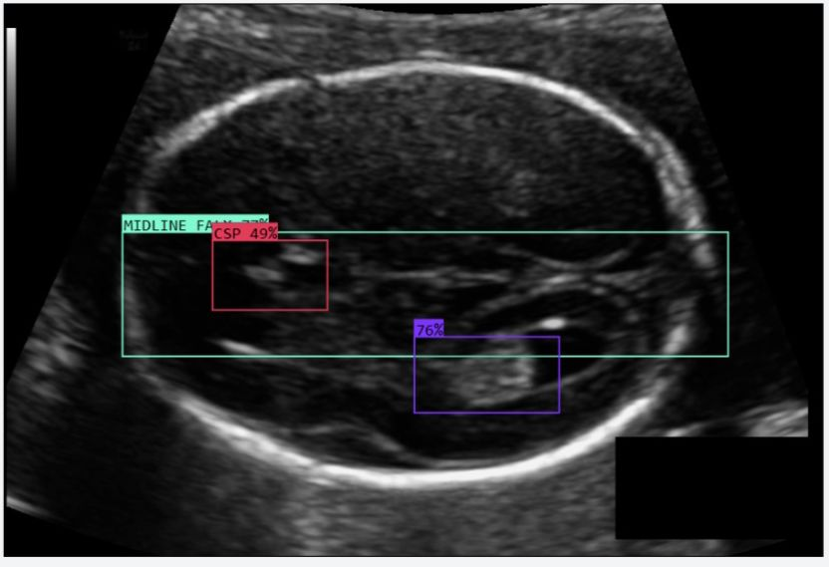

**9. Key Findings**

The key takeaway from the results is that YOLOv8, when properly trained and augmented, shows significant potential in accurately detecting fetal brain structures in ultrasound images. The applied techniques, such as data augmentation and the YOLOv8 architecture, contribute to robustness and accuracy.

9.1 Analytical Insights: After rigorous training and evaluation, the YOLOv8-based model demonstrated promising performance in detecting MIDLINE_FALX, CSP, and CHOROID_PLEXUS structures. The extensive data preprocessing and augmentation contributed to the model's ability to generalize across various ultrasound scenarios, enhancing both accuracy and robustness.

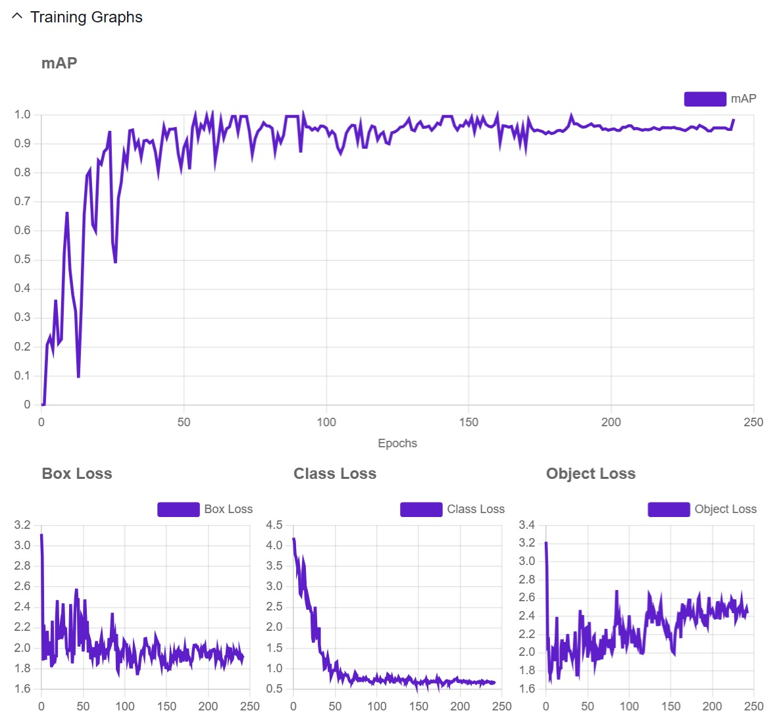

**10. Future Work**

Given more time, I would explore additional avenues for improving model performance. This could involve experimenting with more advanced backbone architectures, investigating advanced loss functions tailored to ultrasound images, and incorporating domain-specific pre-training to enhance feature extraction. Furthermore, refining data augmentation strategies and exploring ensembling techniques could also contribute to improved performance.